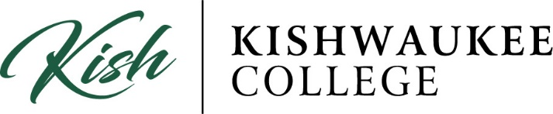

**2025 PAUL SIMON STUDENT ESSAY CONTEST**

**WIN A $500 TUITION REIMBURSEMENT FOR THE SPRING 2025 SEMESTER!**

Kishwaukee College and the Illinois Community College Trustees Association (ICCTA) are sponsoring the Paul Simon Student Essay Contest for community college students on the theme "How My Community College Has Changed My Life." Kish’s winning entry will be entered into the statewide ICCTA competition.

AWARDS

* **From Kishwaukee College**: The Kish winner will receive a $500 Spring 2025 tuition reimbursement. The Kish winner will be recognized at the Kish Board of Trustees at 4 pm Tuesday, April 8, 2025. The winning essay will also be published on the Kish website.
* **From ICCTA**: The state winner will receive a $500 cash stipend for educational expenses during the Fall 2025 semester. The state winner will be invited to the ICCTA annual awards banquet Friday, June 6, 2025, in Normal.

WRITING PROMPT

In a typed essay of 500 words or less, address the theme "How My Community College Has Changed My Life." Entrants may use “How My Community College Has Changed My Life” as the essay’s title. Submissions must be accompanied by a completed entry form.

Each entry will be judged based on writing style, clarity of expression, relevancy to the theme, and correct use of grammar and punctuation.

GUIDELINES

1. Each submission must be no longer than 500 words in length, typed, and double-spaced in essay format.
2. Official entry form must be completed and attached to submission.
3. Submit to Kishwaukee College Marketing & Public Relations electronically at bherrmann3@kish.edu by 4 pm Friday, February 28, 2025.
4. The Kish winner is asked to be present for the recognition and award at the Kish Board of Trustees meeting at 4 pm Tuesday, April 8, 2025.
5. The contest is open to currently enrolled part-time or full-time Illinois community college students.
6. Previous Paul Simon Student Essay Contest winners are welcome to apply, but preference will be given to new applicants.

Kishwaukee College and ICCTA 2025 Paul Simon Student Essay Contest

**Entry Form**

|  |
| --- |
| **Please attach this form to your typed, double-spaced entry and submit it electronically to Marketing & Public Relations at bherrmann3@kish.edu  by 4 pm Friday, Feb. 28, 2025** |

# Name ________________________________________ ID#____________________

**Community College Kishwaukee College**

**Home Address**

**City/State/Zip**

**Phone**

**TITLE OF ESSAY**

**I give Kishwaukee College permission to publish my essay.**

**Check one: Yes**

**No**

* **I attest that I have not used artificial intelligence (AI) to generate this essay submission and submit this entry as an original work, assuming full responsibility.**

**Signature Date**

01/2025